Contact form validation:
https://github.com/Pegasus84/PM03/tree/main/contact%20form%20with%20validation?utm_source=chatgpt.com
DOM events and Dynamic Content:
https://github.com/Pegasus84/PM03/tree/main/DOM%20Events%20and%20Dynamic%20Content?utm_source=chatgpt.com
Display Data from an API:
https://github.com/Pegasus84/PM03/tree/main/Display%20Data%20from%20an%20API?utm_source=chatgpt.com

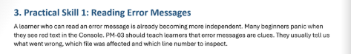
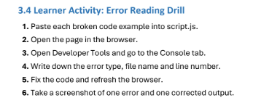
Broken code – Missing closing brace:
Code:
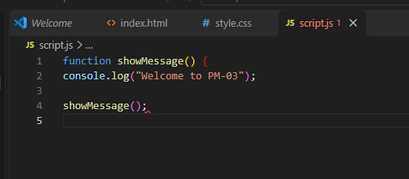
Result:
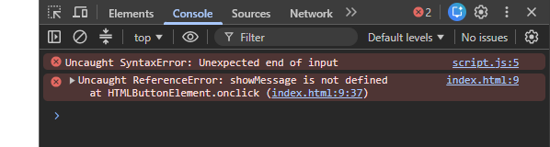
Corrected version:
Code:
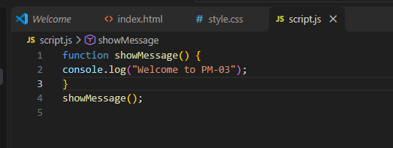
Result:
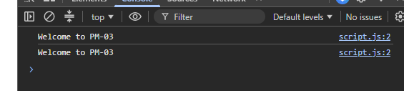
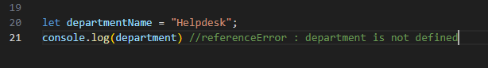
Console:
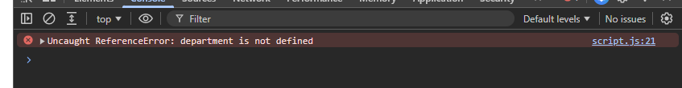
Sources:
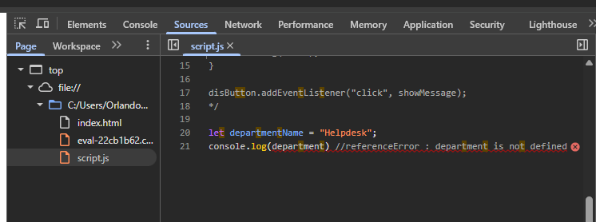
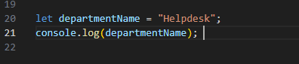
Console: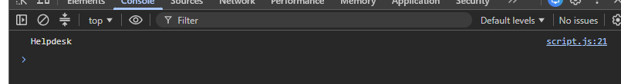
Sources:
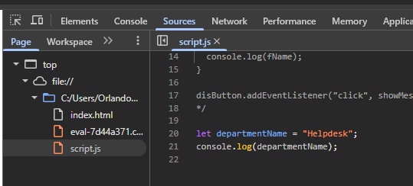

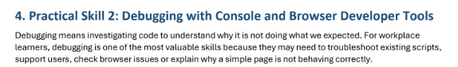
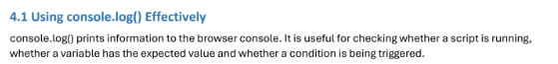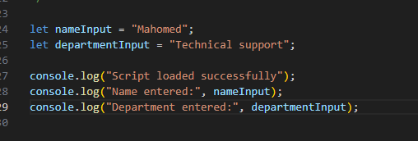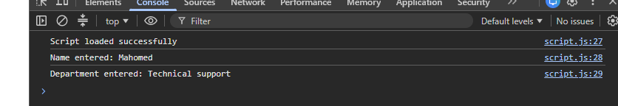

Code:
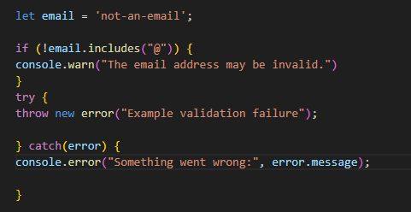
Result:
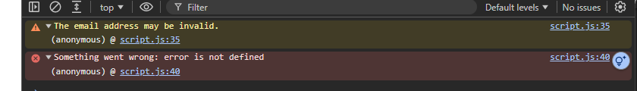
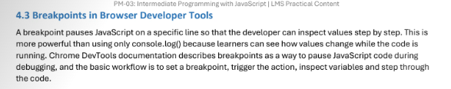
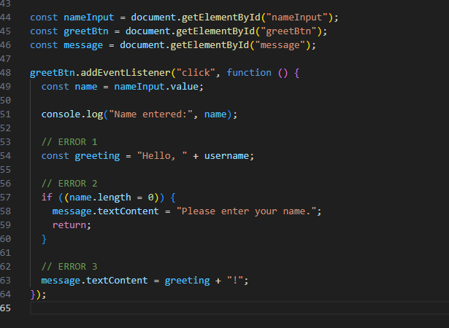
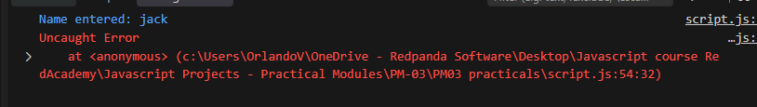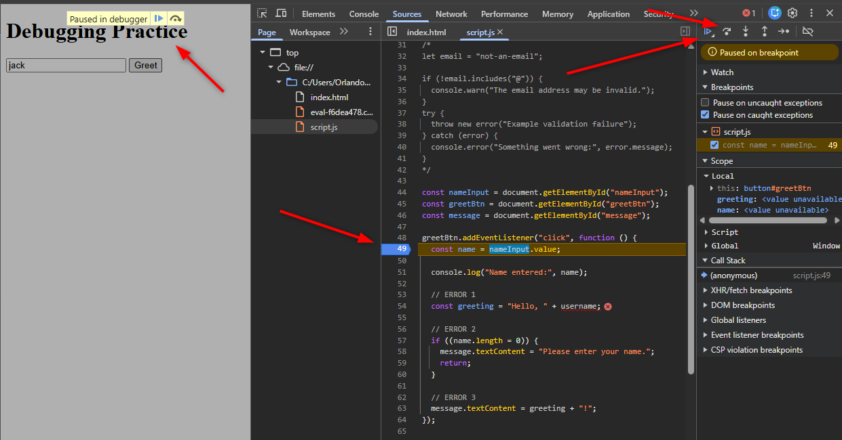

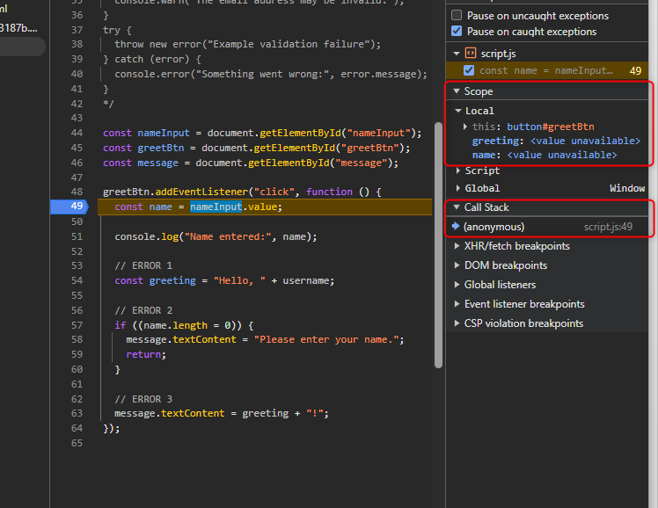

Click step over: In the scope section the variable value displays – this is useful because the application pauses and the developer can see exactly what the variables hold at this given pause state.
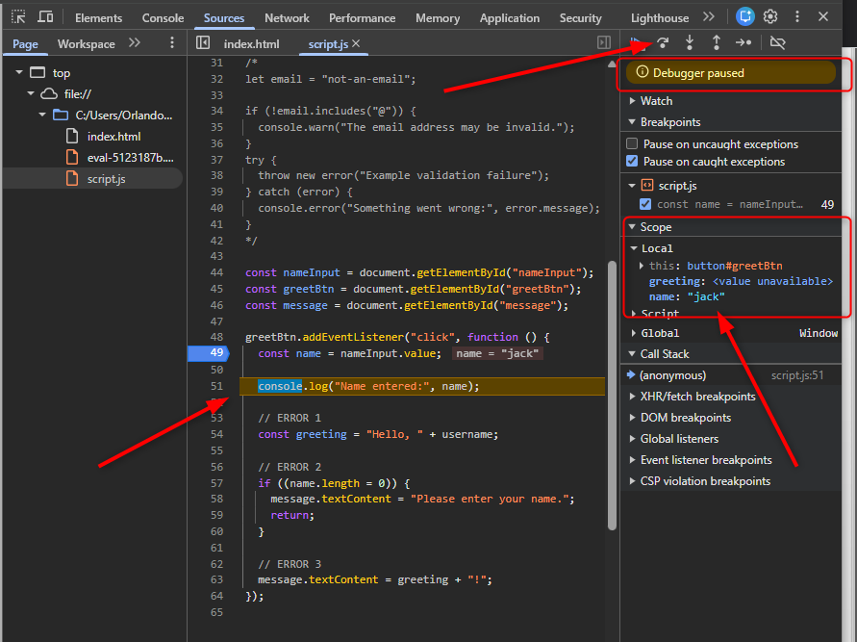
Click step over again:
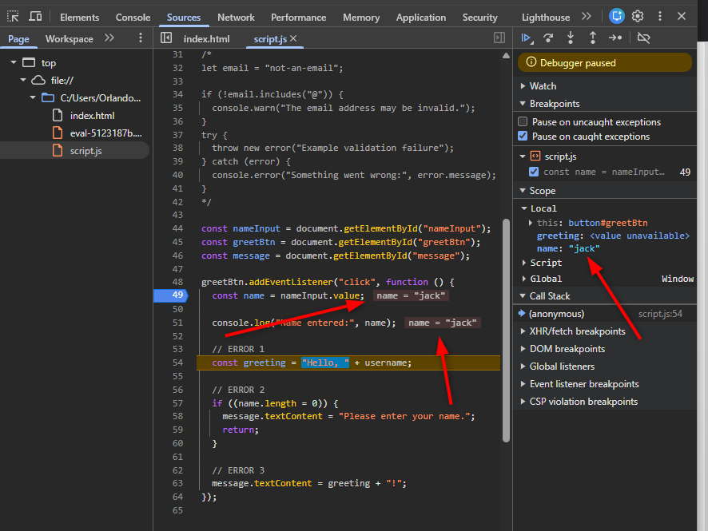
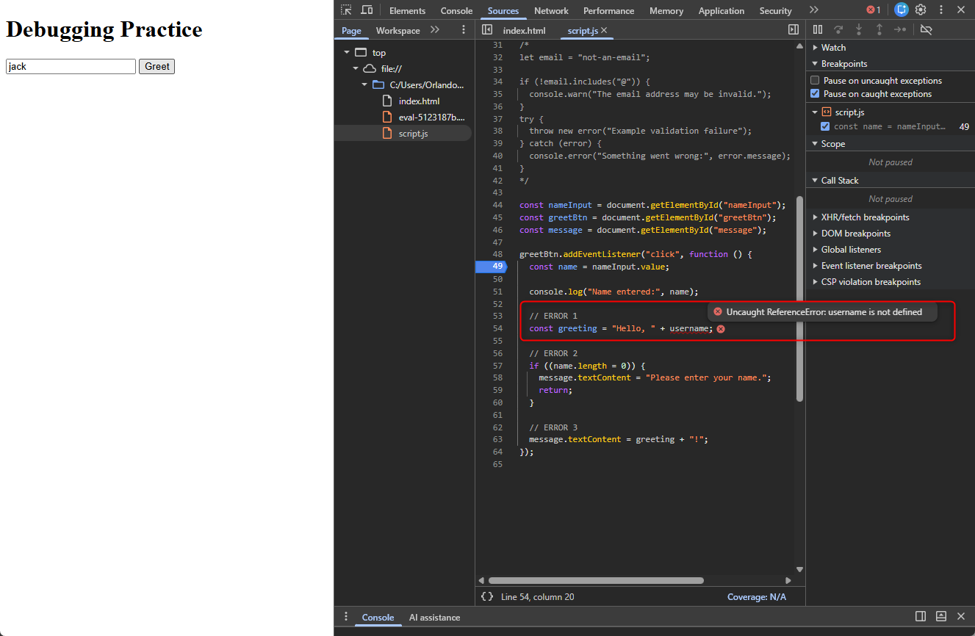
Correct username issue:
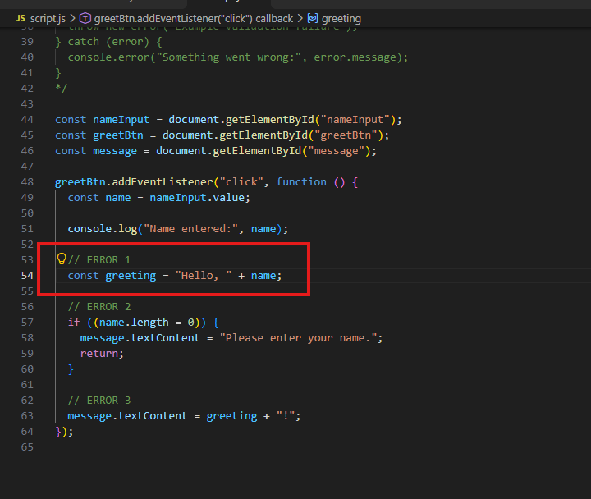

Run application:
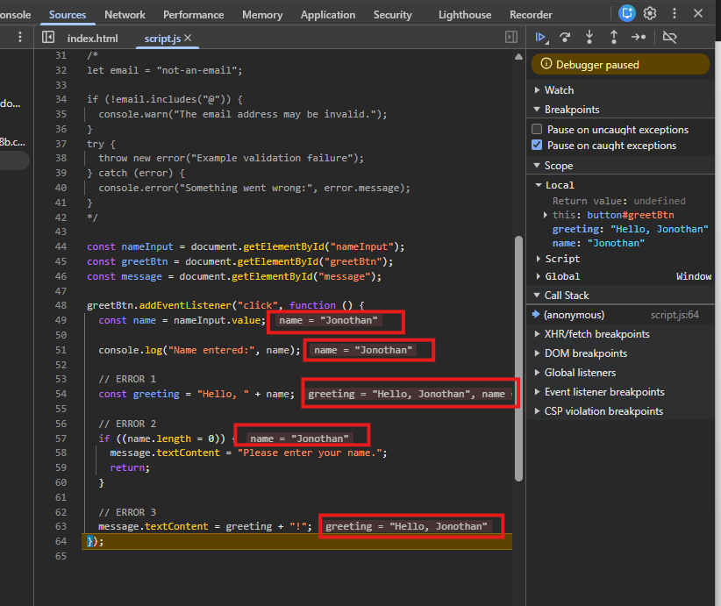
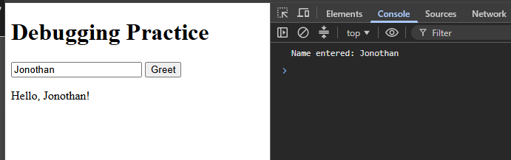

Debug second error:
The assignment operator is incorrect. This should be a comparison operator:
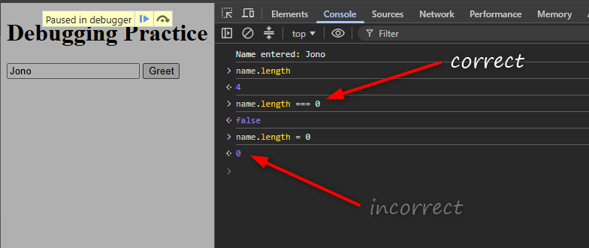
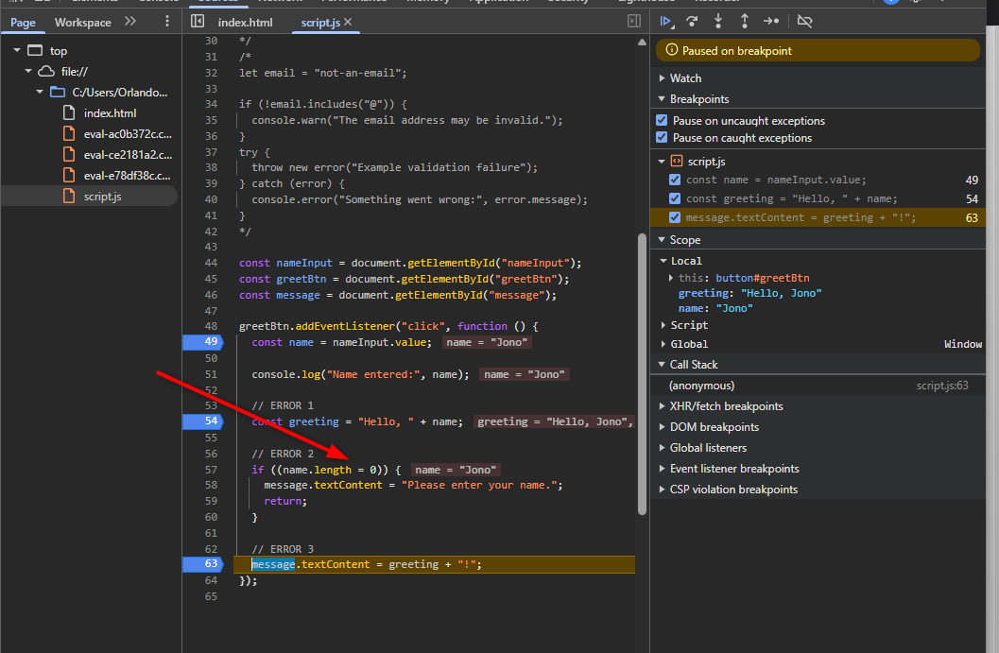

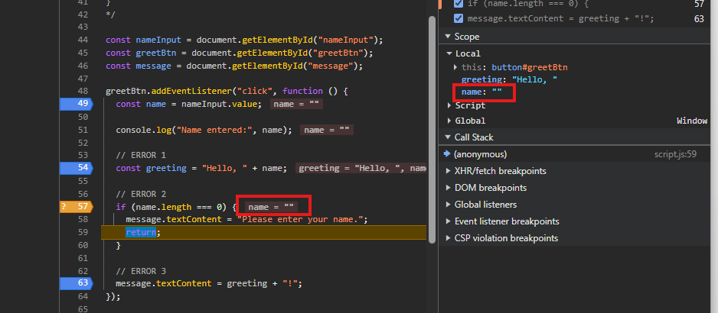
The debugger closes here if I click step over again:
This is correct as I added a conditional breakpoint.
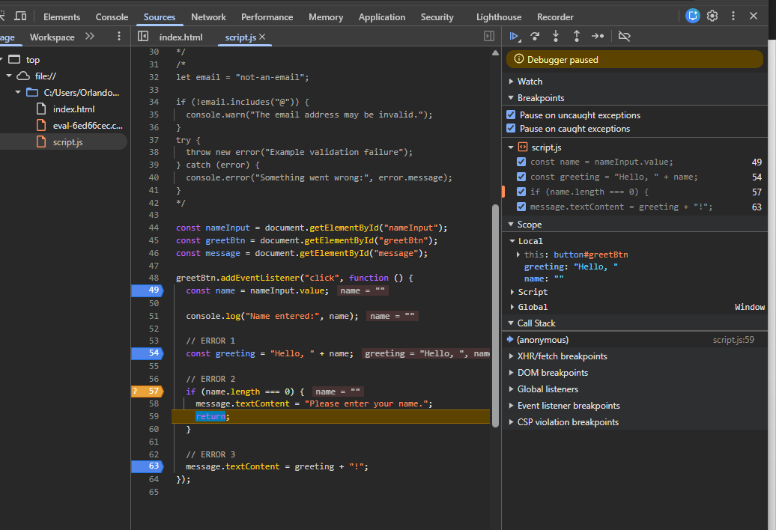
The condition is now working as expected. The condition is meant to return a value of either ‘true’ or ‘false’.
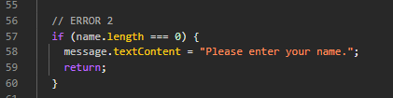
Application running correctly:
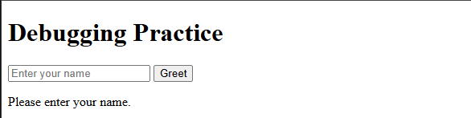

Third error:
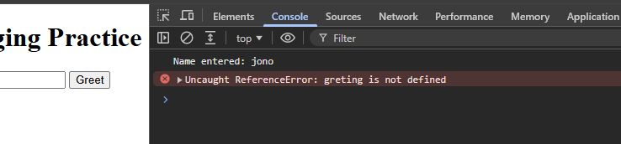
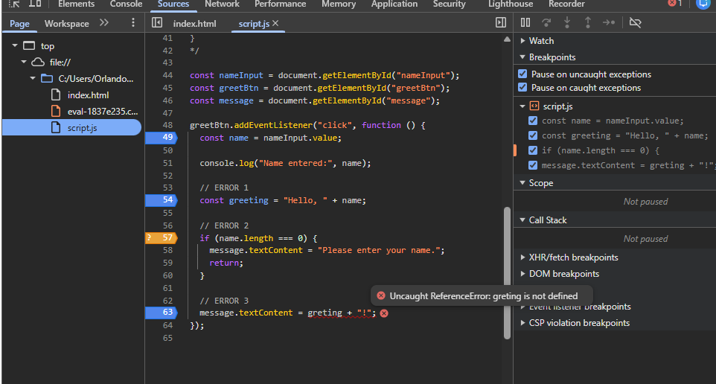
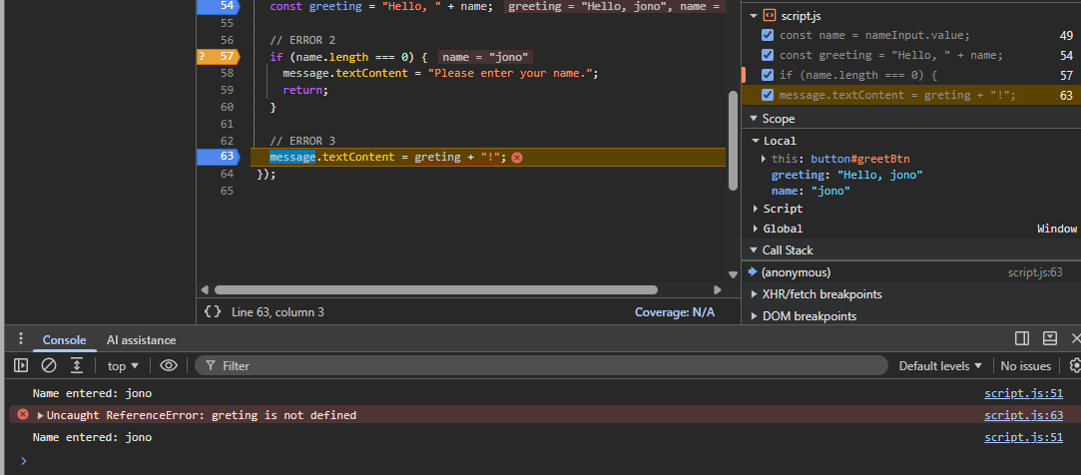
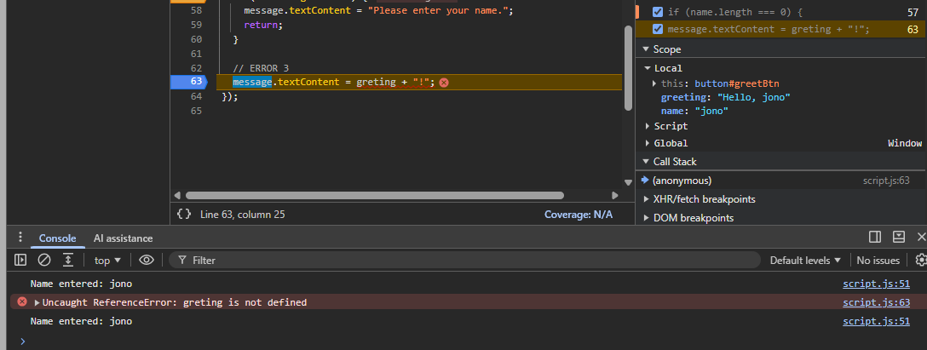

Fix the error:
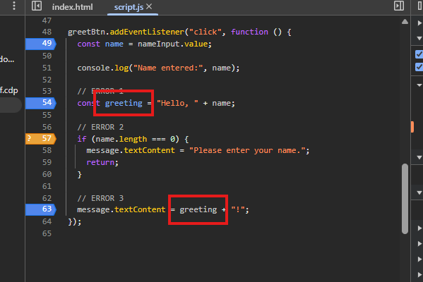
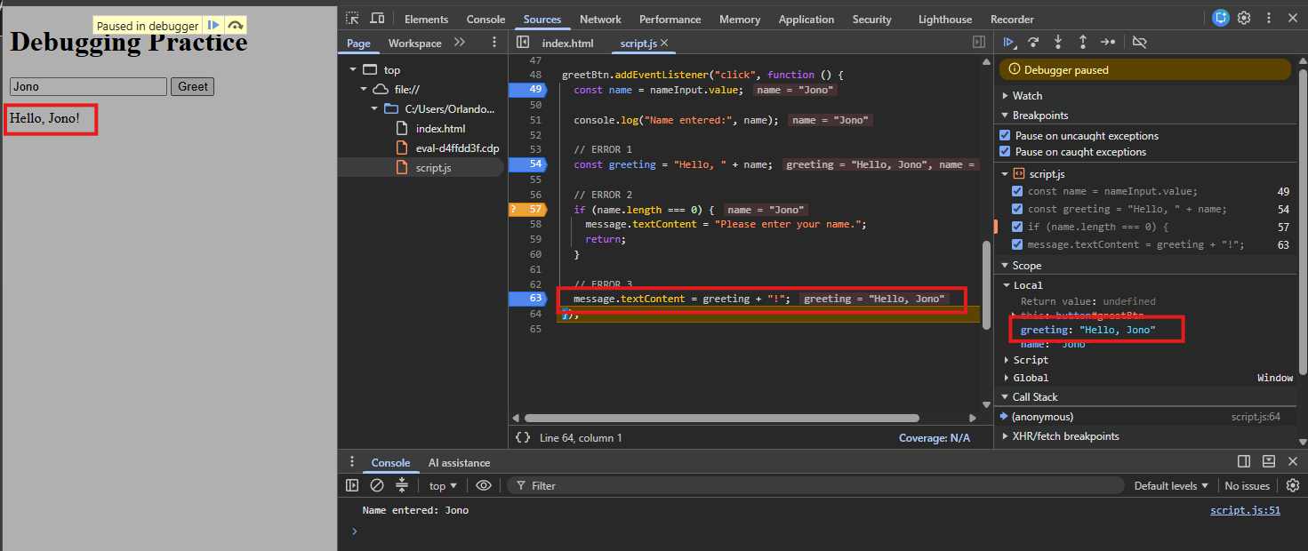
All errors are completed and fixed. The application is working as it should.
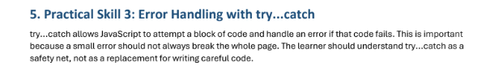
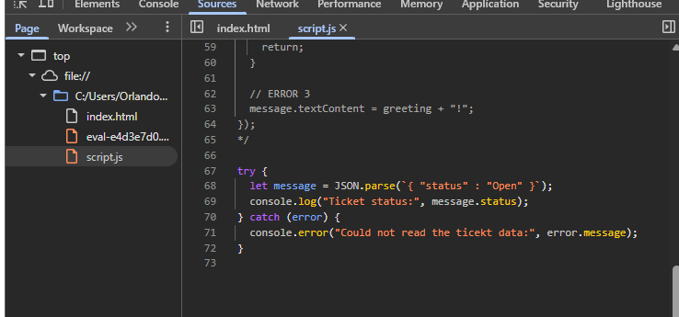
Result in the console:
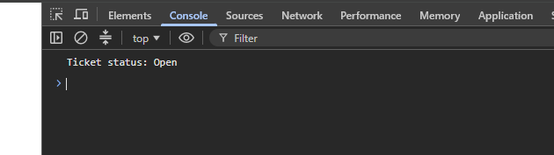
Invalid JSON:
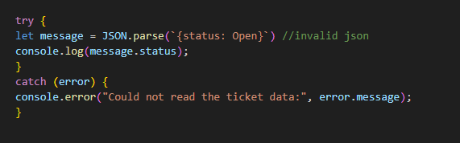
Result:
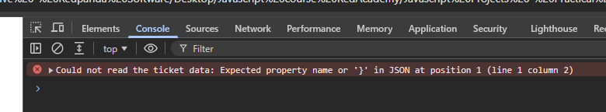

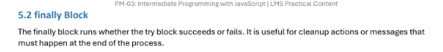
Code:
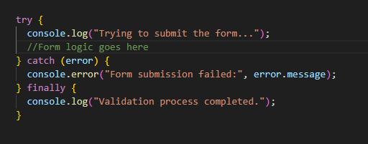

Result:
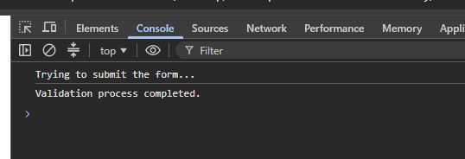
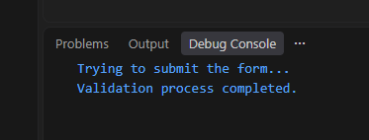

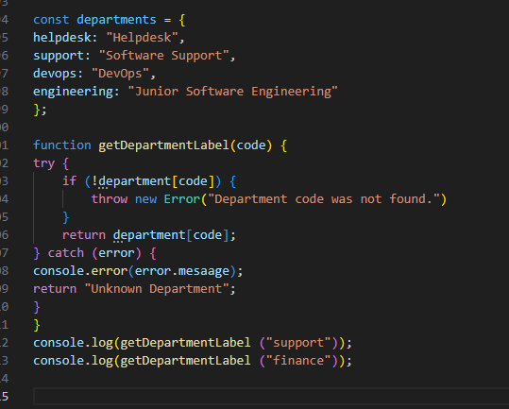
Result:
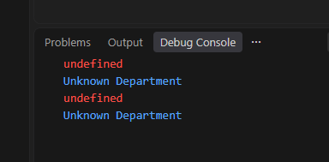
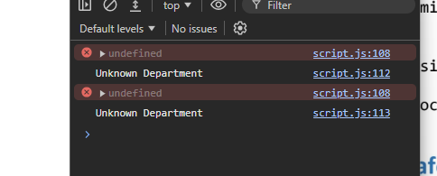
Alternative code: changed ‘department’ to ‘departments’
Code:
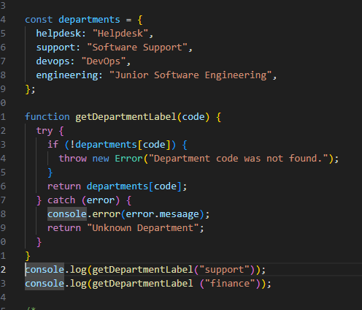
Result:
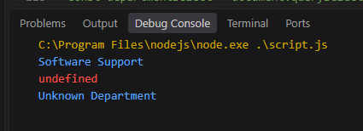
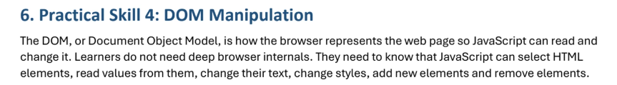
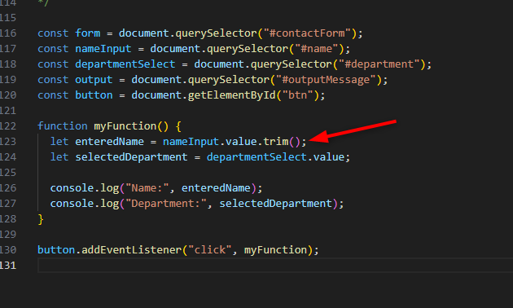
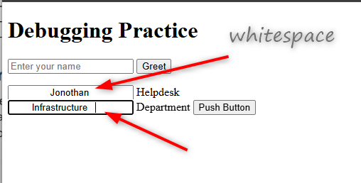
Whitespace is trimmed:
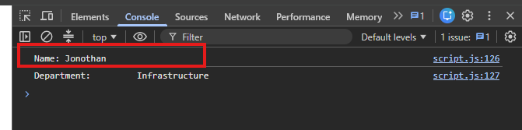
Department Contact and Form with Validations:
HTML:
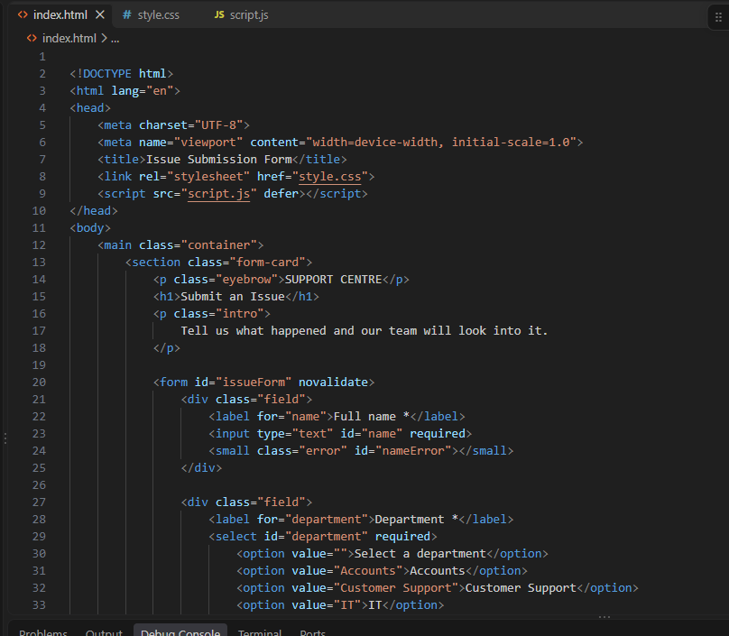
Some CSS:
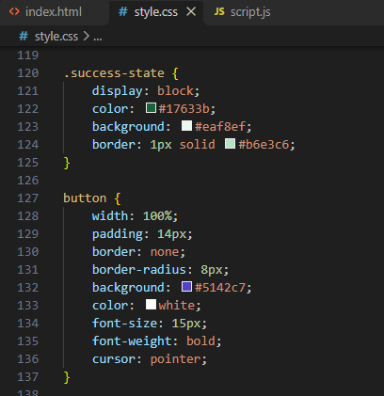

Some javascript:
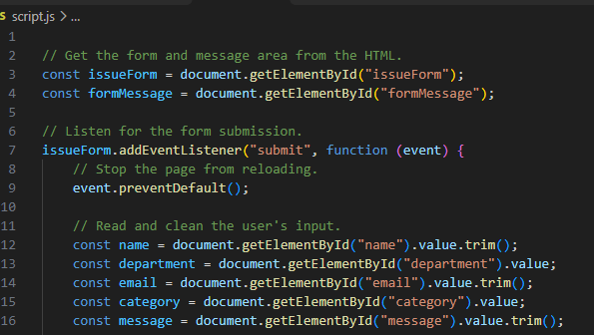
Application:
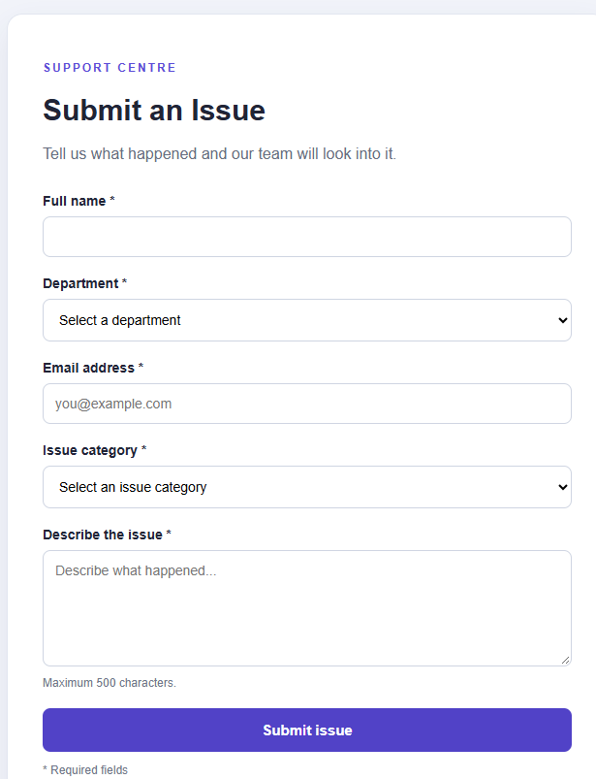

All fields empty:
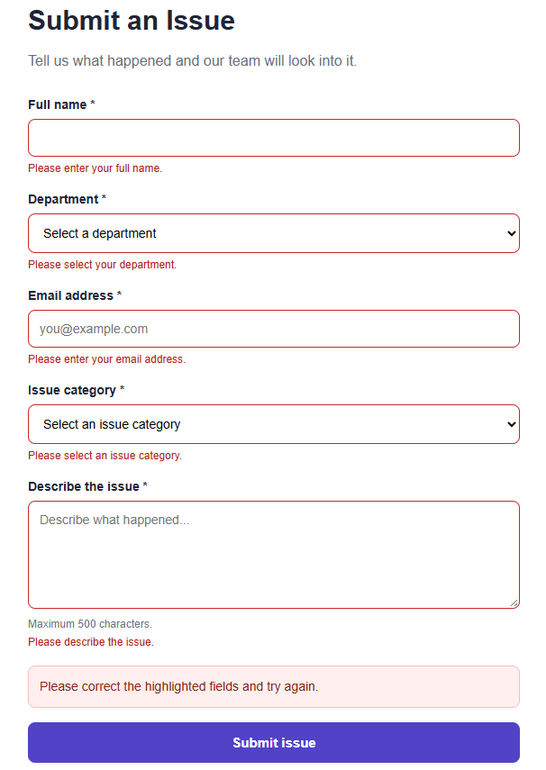

Missing name:
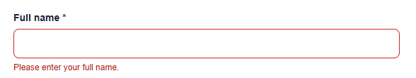
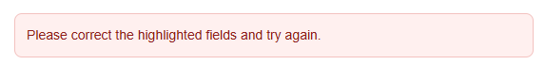
Missing department:
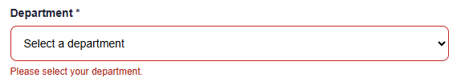
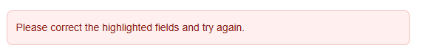
Missing email:
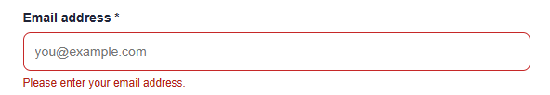
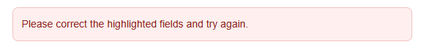
Email address format:
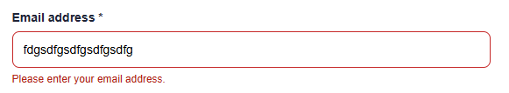
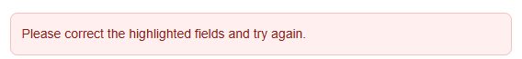
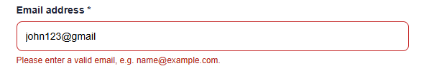
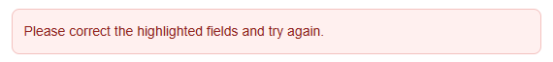
No issue category:
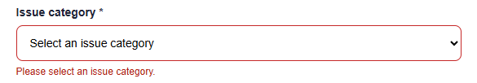
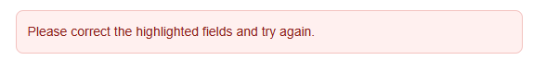
Success:
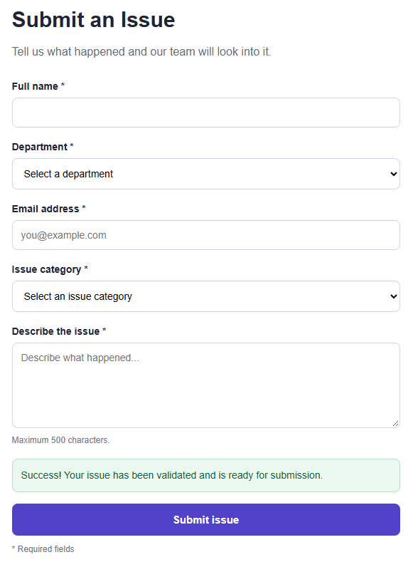
https://github.com/Pegasus84/PM03.git

Dom Events and Dynamic Content:
HTML:
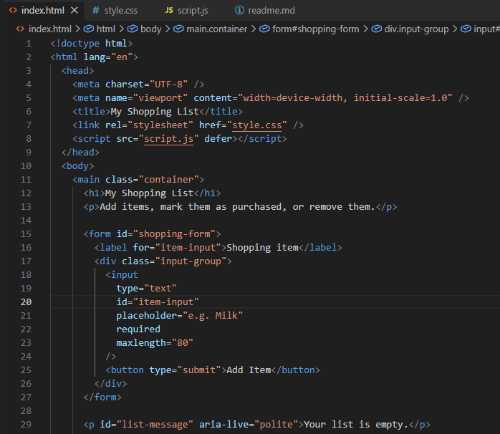
CSS:
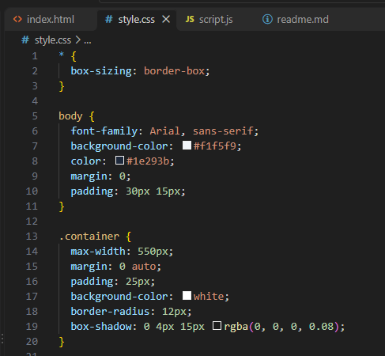

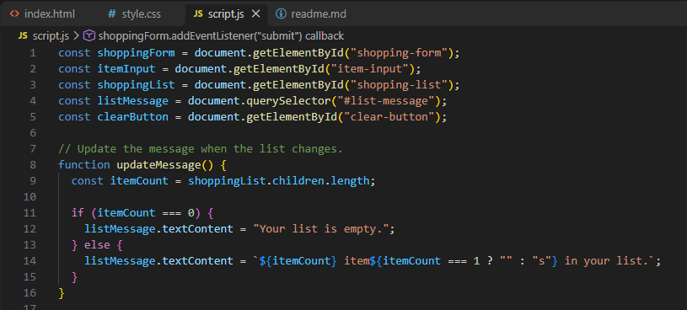
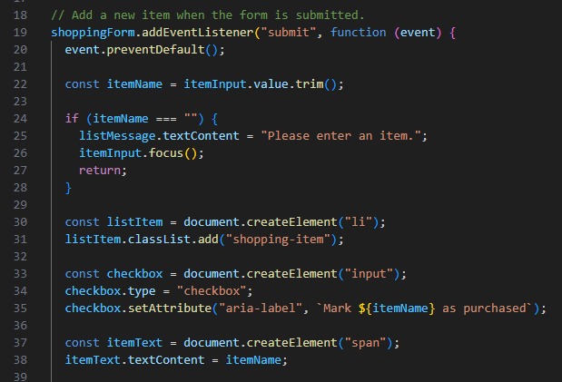
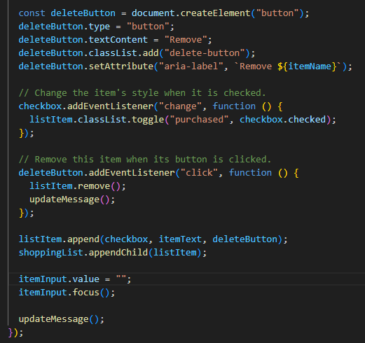
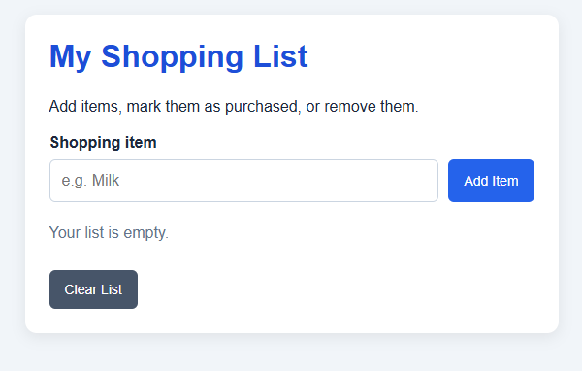

Add items:
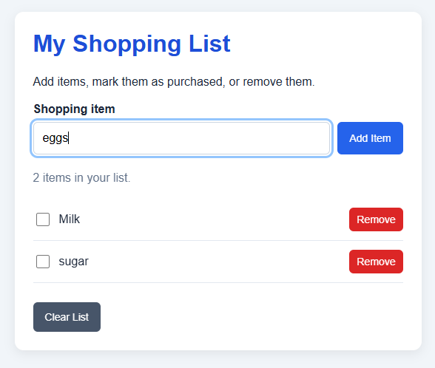

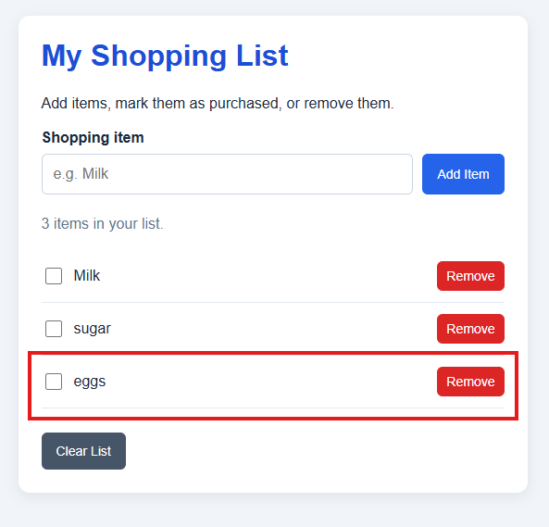
Remove Items:
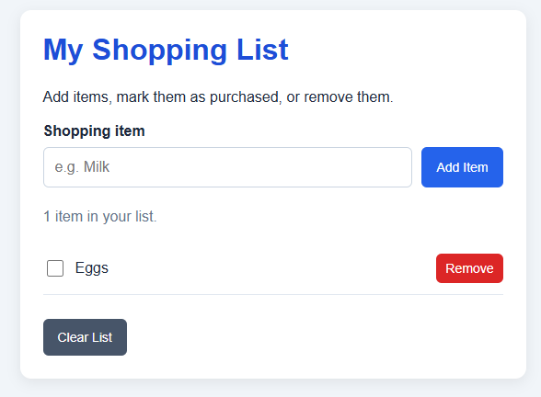

Clear list:
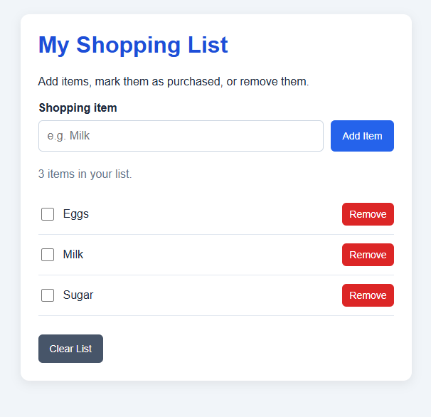
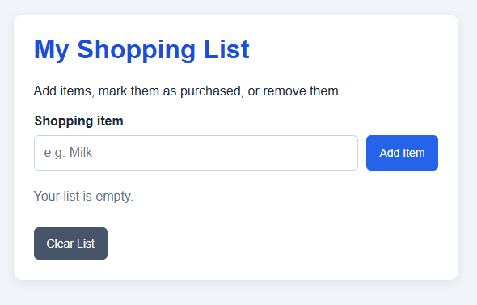

Tick off an item:
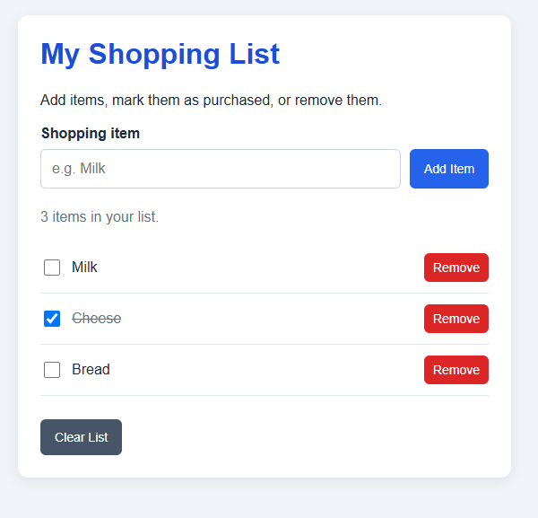
Display Data from an API:
HTML:
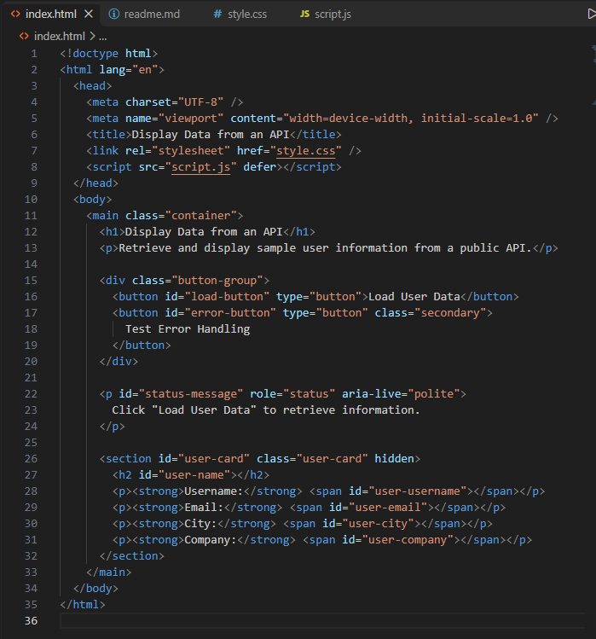
CSS:
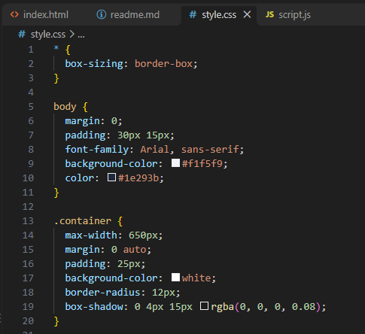
Javascript:
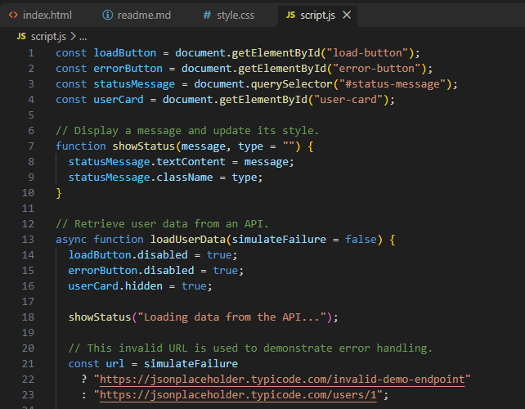
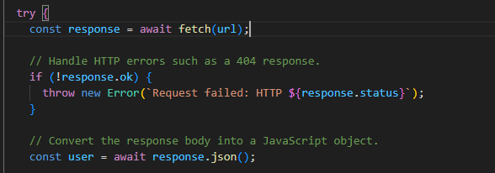
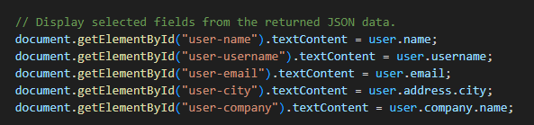

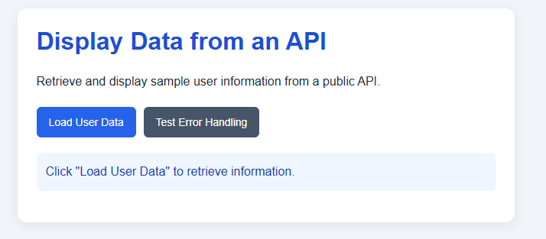
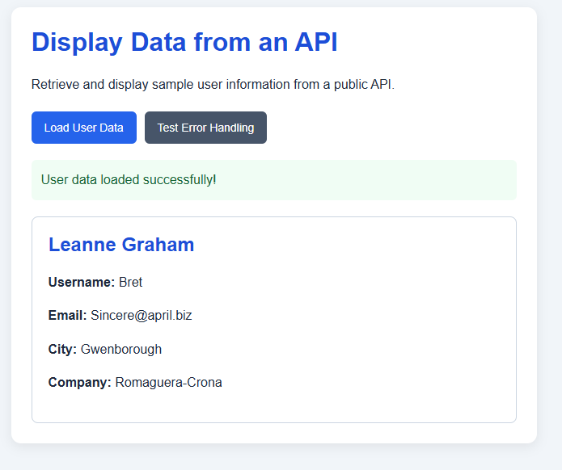

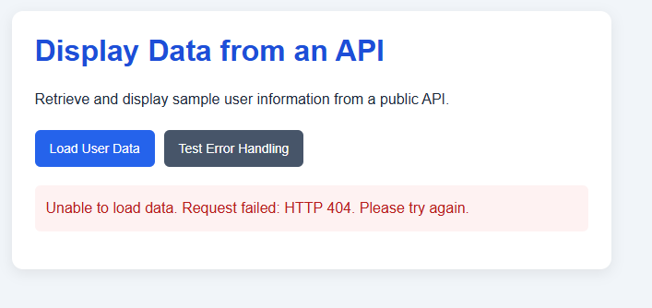
Contact form validation:
https://github.com/Pegasus84/PM03/tree/main/contact%20form%20with%20validation?utm_source=chatgpt.com
DOM events and Dynamic Content:
https://github.com/Pegasus84/PM03/tree/main/DOM%20Events%20and%20Dynamic%20Content?utm_source=chatgpt.com
Display Data from an API:
https://github.com/Pegasus84/PM03/tree/main/Display%20Data%20from%20an%20API?utm_source=chatgpt.com

--------------------------------------------------------------------------------------------------------------

